
Emotion Correlation Mining Through Deep Learning Models on Natural Language Text
A PROJECT REPORT

Submitted by

SNEHA.B [REGISTERNO:211417104262] R.SWARNALASHMI [REGISTERNO:211417104281] ZULAIHA FATHIMA.V.I [REGISTERNO:211417104331]

In partial fulfillment for the award of the degree
of

BACHELOR OF ENGINEERING

IN

COMPUTER SCIENCE AND ENGINEERING

PANIMALAR ENGINEERING COLLEGE, CHENNAI-600123.
ANNA UNIVERSITY: CHENNAI 600025

APRIL2021
BONAFIDE CERTIFICATE

Certified that this project report “ EMOTION CORRELATION MININGTHROUGH DEEP LEARNING MODELS ON NATURAL LANGUAGE TEXT ” is the bonafide work of “ SNEHA.B [REGISTERNO:211417104262],R.SWARNALASHMI [REGISTERNO:211417104281], ZULAIHAFATHIMA.V.I
[REGISTERNO:211417104331] ” who carried out the project work under my supervision.

SIGNATURE SIGNATURE Dr.S.MURUGAVALLI,M.E.,Ph.D., Dr.T.JACKULIN,M.E.,Ph.D.,
HEAD OF THE DEPARTMENT Assistant Professor

DEPARTMENT OF CSE, DEPARTMENT OF CSE,
PANIMALAR ENGINEERING COLLEGE, PANIMALAR ENGINEERING COLLEGE, NAZARATHPETTAI, NAZARATHPETTAI,
POONAMALLEE POONAMALLEE,
CHENNAI-600123. CHENNAI-600123.

Certified that the above candidate(s) was/were examined in the Anna University Project Viva- Voce Examination held on...........................

INTERNAL EXAMINER EXTERNAL EXAMINER

ACKNOWLEDGEMENT

We express our deep gratitude to our respected Secretary and Correspondent Dr.P.CHINNADURAI, M.A., Ph.D.,for his kind words and enthusiastic motivation, which inspired us a lot in completing this project.

We would like express our heartfelt and sincere thanks to our Directors
Tmt.C.VIJAYARAJESWARI, Dr.C. SAKTHIKUMAR,M.E.,Ph.D., and
Tmt.SARANYA SREE SAKTHIKUMAR B.E.,M.B.A., for providing us with the necessary facilities for completion of this project.

We also express our gratitude to our Principal Dr.K.Mani, M.E., Ph.D.,for his timely concern and encouragement provided to us throughout the course.

We thank the HOD of CSE Department, Dr. S.MURUGAVALLI ,M.E.,Ph.D., for the support extended throughout the project.

We would like to thank my Project Guide Mrs. Dr.T.JACKULIN,M.E.,Ph.D.,
and all the faculty members of the Department of CSE for their advice and suggestions for the successful completion of the project.
NAME OF THE STUDENTS SNEHA.B R.SWARNALASHMI ZULAIHA FATHIMA.V.I
iii

ABSTRACT

Emotion analysis from text is one of the hot topics in modern natural language understanding. Embedding and attention mechanisms help a lot with emotion recognition in deep learning methods. Emotion analysis has been attracting researcher’s attention. Most previous works in the artificial-intelligence field focus on recognizing emotion rather than mining the reason why emotions are not or wrongly recognized. The CNN and Collaborative algorithm is used here. the given input data are tweets pre-processed and then the classification is done and final results will be integrated such as the given number of title, emotion, hash tags, and commands will be collected and separately given as the output. The correlation among emotions contributes to the failure of emotion recognition. To mine emotion correlation from emotion recognition through text, three kinds of features and two deep neural-network models are presented. The emotion confusion law is extracted through an orthogonal basis. Emotion analysis, as an important traditional branch of knowledge mining, is categorized into three levels, namely: word level, sentence level, and document level.

TABLE OF CONTENTS

CHAPTER NO. | TITLE | PAGENO.
 | ABSTRACT | iii
 | LIST OF SYMBOLS, ABBREVIATIONS | vii
 | LIST OF TABLES | viii
 | LIST OF FIGURES | ix
1. | INTRODUCTION
 | 1.1 Overview | 1
 | 1.2 Problem Definition | 1
2. | LITERATURE SURVEY  2.1 Literature Survey | 2
3. | SYSTEM ANALYSIS
 | 3.1 Existing System | 10
 | 3.2 Proposed system | 10
 | 3.3 Requirement Analysis and Specification | 11
 | 3.3.1 Input Design | 11
 | 3.3.2 Output Design | 12

Hardware Requirement 12

Software Requirement 12
CHAPTER NO TITLE PAGE NO

4. SYSTEM DESIGN

4.1 ER Diagram 14
4.2 Data Dictionary 15
4.3 UML Diagram 16

5. SYSTEM ARCHITECTURE
5.1 Architecture Overview 21
5.2 Module Design Specification 23

6. SYSTEM IMPLEMENTATION
6.1 System Implementation 25

7. SYSTEM TESTING
7.1 Unit Testing 37
7.2 Integration Testing 39
7.3 Acceptance Testing 39
7.4 Test Cases & Report 39

8. CONCLUSION
8.1 Conclusion 44
APPENDICES
A.1 Sample Screens 46
REFERENCES

LIST OF ABBREVIATIONS

CNN | Convolutional Neural Network
ER | Entity Relationship
ERD | Entity Relationship Diagram
DFD | Data-Flow Diagram
GUI | Graphical User Interface
SQL | Structured Query Language
UML | Unified Modeling Language
IDF | Inverse Document Frequency
SQL | Structured Query Language
TF | Term Frequency

LIST OF TABLES

TABLE NO TABLE NAME PAGE NO

Table 4.1 Data Dictionary 15

LIST OF FIGURES

FIGURE NO FIGURE NAME PAGE NO

FIGURE 4.1 ER 14

FIGURE 4.2 Use Case Diagram 16

FIGURE 4.3 Class Diagram 17

FIGURE 4.4 Sequence Diagram 18

FIGURE 4.5 Deployment Diagram 19

FIGURE 5.1 System Architecture 21

INTRODUCTION
    - INTRODUCTION

OVERVIEW

Most previous works in the artificial-intelligence field focus on recognizing emotion rather than mining the reason why emotions are not or wrongly recognized. The correlation among emotions contributes to the failure of emotion recognition. In this article, we try to fill the gap between emotion recognition and emotion correlation mining through natural language text from Web news. The correlation among emotions, expressed as the confusion and evolution of emotion, is primarily caused by human emotion cognitive bias. To mine emotion correlation from emotion recognition through text, three kinds of features and two deep neural- network models are presented. The emotion confusion law is extracted through an orthogonal basis. The emotion evolution law is evaluated from three perspectives: one-step shift, limited-step shifts, and shortest path transfer. The method is validated using three datasets: 1) the titles2) the bodies and 3) the comments of news articles, covering both objective and subjective texts in varying lengths (long and short). The experimental results show that in subjective comments, emotions are easily mistaken as anger. Comments tend to arouse emotion circulations of love–anger and sadness–anger

PROBLEM DEFINITION

    - The complexity is composed of two parts, that is, the diversity of emotions and the complexity of social events. The complexity of the problem will inevitably lead to errors without considering other factors.

    - The emotion of individuals is complex and is impacted by individualized long-term social experiences, misunderstandings caused by prior background knowledge, and external instant mood influences.

    - The application of the subjective and emotional data from social media includes but is not limited to sentiment analysis. The number of features in explicit expression is not less than that in implicit expression, as synonyms share the same tag in implicit expression
OBJECTIVES:

- To improve the performance of the Emotion correlation system, we use data processing, feature extraction, group recommendation, clustering the group, hastag classification using CNN and collaborative algorithm

- To establish an approach to automatically detect groups of interest in a given event, based on a semantic analysis of the tweets they post.

- To ensure that the feasibility and the accuracy of the proposed system is higher than the existing system.

- To develop an improved method to categories into various communities.

LITERATURE SURVEY

LITERATURE SURVEY

[1] Q. Su, J. Huang et al designed an information propagation model considering incomplete reading behavior in micro blog. Individuals spread information about their lives, their career, and their recently purchased items. In addition, considering that the customer’s opinions may influence their friendship circle, neighbors, and work colleagues, they constitute a very important factor to consider in future actions of companies. In we present an approach based on probabilistic cellular automata and ordinary differential equations for modeling the consumer market, inspired by a biological system of an infectious disease- spreading model. However, instead of spreading a disease, consumers spread their opinion to other individuals, thereby having consequences on sales levels. Using marketing, the economic situation, and individual opinion as input variables of the consumer market model, simulation output (generated demand) is then used in the business game, helping the mediator (teacher) to create different scenarios and giving feedback to the student at simulation runtime, even if many players are involved in the game. Analytical and numerical simulations show that the proposed approach allows the teacher to create virtual markets for the players just by setting the parameters that describe a scenario, increasing the dynamism of the game, saving time, and allowing the mediator to focus on other important subjects, such as the teaching concepts of business strategies and decision support. Moreover, simulations are conducted to demonstrate the applicability of the proposed model in real life problems, such as the electro-domestic market.

[2] Voelkl, B et al developed the influence of social structure on the propagation of social information in artificial primate groups: a graph-based simulation approach. Observations of primate groups have shown that social learning can lead to information transmission that (1) preserves the complexity of the social structure primate groups and (2) allows direct application to empirical data. Results from simulation experiments with artificial group structures confirm that association patterns of group-members influence the expected speed of information transmission during the propagation process. Introducing a forgetting rate shows that under certain conditions to proportion of informed individuals will reach a stable rate in some systems while it will drop to zero in others. This suggests that the likelihood to observe temporal stable traditions shall differ between social systems with different structure.
[3] R. Jie, et al A study on the interaction between two rumours in homogeneous complex networks under symmetric conditions,” This paper focuses on the modelling of a rum or spreading in heterogeneous networks. Using the probability generating function method and pair approximation method, the current research obtains nonlinear differential equations to describe the dynamics of rumour spreading. The comparison between numerical simulations and Monte Carlo simulations confirms the accuracy of our model. Furthermore, the threshold condition is also obtained in this paper. The numerical simulation results show that the heterogeneity of the network accelerates the outbreak of rumours but reduces the maximum density of spreader and the scale of rumours. The present study also examines the effects of parameters on rumour trans ission and the differences between rumour transmission recovery mechanisms and disease transmission recovery mechanisms.

[4] Z. L. Zhang et al developed the interplay model for rumour spreading and emergency development Rumours influence how people make decisions in an emergency-affected environment. Conversely, the development of situation is affected by public action as well. We present a model for describing the interplay between rumour spreading and emergency development. Then, we describe a formulation of this model and derive, from differential equations for some possibility of the positive role of rumours in the control of situation and social loss. Our results show that rumour spreading at certain rate has positive effects on situation stability and especially has delaying effects on the rapid proliferation of an emergency. Finally, we outline a strategy for authorities that can contribute to rumour management in an emergency event.

[5] D. Liu et al designed Rumor propagation in online social networks like Twitter - A simulation study,” Rumor has drawn much of the attention of researchers, considering its importance and influence, as well as its complexity. Under different circumstances, the process and results of rumor spreading are also different. The method of agent-based modeling is considered a good way to look into the process of rumour propagation. In this study, we put the theme under the circumstances of online social networks like twitter, which is different from traditional social network websites. Assuming that the structure of these websites is a kind of scale free network, we build a specific agent-based model using Net Logo based on the propagation model of SIR. Taking consideration of the unique property of twitter-like websites in information flow, max spread time and the mechanism of people believing the rumor, we draw the conclusion that compared to the traditional online social networks, the rumor propagation in twitter-like websites is of more efficiency, unpredictability, and a tendency to start the rumour

[6] Xinzhi Wang et al developed the Social sentiment detection of event via microblog entimental analyses of the public have been attracting increasing attentions from researchers. This paper focuses on the research problem of so calledcial sentiment detection, which aims to identify the sentiments of the public evoked by online microblogs. A general social sentiment model is proposed for this task. The general social sentiment model combining society and phycology knowledge are employed to measure social sentiment state. Then, we detail computation of sentiment vector to extract sentiment distribution of blogger on event. Besides, social state for events are computed based on the general social sentiment model and sentiment vectors. Furthermore, we certify that social sentiment are not independent but are correlated with each other heterogeneously in different events. The dependencies between sentiments can provide guidance in decision-making for government or organization. At last experiments on two real-world collections of events microblogs are conducted to prove the performance of our method

[7] Anthony Hu et al designed the Multimodal sentiment analysis to explore the structure of emotions We propose a novel approach to multimodal sentiment analysis using deep neural networks combining visual analysis and natural language processing. Our goal is different than the standard sentiment analysis goal of predicting whether a sentence expresses positive or negative sentiment; instead, we aim to infer the latent emotional state of the user. Thus, we focus on predicting the emotion word tags attached by users to their Tumblr posts, treating these as" self-reported emotions." We demonstrate that our multimodal model combining both text and image features outperforms separate models based solely on either images or text. Our model's results are interpretable, automatically yielding sensible word lists associated with emotions. We explore the structure of emotions implied by our model and compare it to what has been posited in the psychology literature, and validate our model on a set of images that have been used in psychology studies. Finally, our work also provides a useful tool for the growing academic study of images-both photographs and memes-on social networks.
[8] Stefan Stieglitz et al designed the Emotions and information diffusion in social media— sentiment of microblogs and sharing behavior As a new communication paradigm, social media has promoted information dissemination in social networks. Previous research has identified several content-related features as well as user and network characteristics that may drive information diffusion. However, little research has focused on the relationship between emotions and information diffusion in a social media setting. In this paper, we examine whether sentiment occurring in social media content is associated with a user's information sharing behavior. We carry out our research in the context of political communication on Twitter. Based on two data sets of more than 165,000 tweets in total, we find that emotionally charged Twitter messages tend to be retweeted more often and more quickly compared to neutral ones. As a practical implication, companies should pay more attention to the analysis of sentiment related to their brands and products in social media communication as well as in designing advertising content that triggers emotions.

[9] Yukun Zhao et al developed the Explainable user clustering in short text streams User clustering has been studied from different angles: behavior-based, to identify similar browsing or search patterns, and content-based, to identify shared interests. Once user clusters have been found, they can be used for recommendation and personalization. So far, content-based user clustering has mostly focused on static sets of relatively long documents. Given the dynamic nature of social media, there is a need to dynamically cluster users in the context of short text streams. User clustering in this setting is more challenging than in the case of long documents as it is difficult to capture the users' dynamic topic distributions in sparse data settings. To address this problem, we propose a dynamic user clustering topic model (or UCT for short). UCT adaptively tracks changes of each user's time-varying topic distribution based both on the short texts the user posts during a given time period and on the previously estimated distribution. To infer changes, we propose a Gibbs sampling algorithm where a set of word-pairs from each user is constructed for sampling. The clustering results are explainable and human-understandable, in contrast to many other clustering algorithms. For evaluation purposes, we work with a dataset consisting of users and tweets from each user. Experimental results demonstrate the effectiveness of our proposed clustering model compared to state-of-the-art baselines.

[10] Nal Kalchbrenner et al designed the convolutional neural network for modelling sentences The ability to accurately represent sentences is central to language understanding. We describe a convolutional architecture dubbed the Dynamic Convolutional Neural Network (DCNN) that we adopt for the semantic modelling of sentences. The network uses Dynamic k-Max Pooling, a global pooling operation over linear sequences. The network handles input sentences of varying length and induces a feature graph over the sentence that is capable of explicitly capturing short and long-range relations. The network does not rely on a parse tree and is easily applicable to any language. We test the DCNN in four experiments: small scale binary and multi-class sentiment prediction, six-way question classification and Twitter sentiment prediction by distant supervision. The network achieves excellent performance in the first three tasks and a greater than 25% error reduction in the last task with respect to the strongest baseline.

SYSTEM ANALYSIS

SYSTEM ANALYSIS

3.1 EXISTING SYSTEM

The use of social networks for political participation and demonstrations is anew and evolving phenomenon occurring in events. Most previous works in the artificial-intelligence field focus on recognizing emotion rather than mining the reason why emotions are not or wrongly recognized. The correlation among emotions contributes to the failure of emotion recognition. The latest is a research domain that is catching the attention of the academic community, and refers to the misuse of hash tags for a different purpose that the one that was originally set, generating confusion to users interested in the topic associated to the original hash tag.

.3.2 PROPOSED SYSTEM

To mine emotion correlation from emotion recognition through text, three kinds of features and two deep neural-network models are presented. The emotion confusion law is extracted through an orthogonal basis. The emotion evolution law is evaluated from three perspectives: one-step shift, limited-step shifts, and shortest path transfer. The method is validated using three datasets: covering both objective and subjective texts in varying lengths (long and short). The experimental results show that in subjective comments, emotions are easily mistaken as anger. Comments tend to arouse emotion circulations of love–anger and sadness–anger. The CNN and Collaborative algorithm is used here. the given input data are tweets per-processed and then the classification is done and final results will be integrated such as the given number of title, emotion, hash tags, and commands will be collected and separately given as the output.

REQUIREMENT ANALYSIS AND SPECIFICATION

INPUT DESIGN

The input design is the link between the information system and the user. It comprises the developing specification and procedures for data preparation and those steps are necessary to put transaction data in to a usable form for processing can be achieved by inspecting the computer to read data from a written or printed document or it can occur by having people keying the data directly into the system. The design of input focuses on controlling the amount of input required, controlling the errors, avoiding delay, avoiding extra steps and keeping the process simple. The input is designed in such a way so that it provides security and ease of use with retaining the privacy. Input Design considered the following things:
      - What data should be given as input?
      - How the data should be arranged or coded?
      - The dialog to guide the operating personnel in providing input.
      - Methods for preparing input validations and steps to follow when error occur.

OBJECTIVE:

- Input Design is the process of converting a user-oriented description of the input into a computer- based system.
- It is achieved by creating user-friendly screens for the data entry to handle large volume of data. The goal of designing input is to make data entry easier and to be free from errors.
3 .When the data is entered it will check for its validity. Data can be entered with the help of screens.

OUTPUT DESIGN

A quality output is one, which meets the requirements of the end user and presents the information clearly. In any system results of processing are communicated to the users and to other system through outputs. In output design it is determined how the information is to be displaced for immediate need and also the hard copy output. It is the most important and direct source information to the user. Efficient and intelligent output design improves the system’s relationship to help user decision- making.

HARDWARE REQUIREMENT

System : Pentium IV 2.4 GHz. Hard Disk : 40GB.
Floppy Drive : 1.44 Mb. Monitor : 15 VGA Colour.
Mouse : Logitech.
Ram : 512Mb.

SOFTWARE REQUIREMENT

Operating system : Windows XP. Coding Language :JAVA
Data Base :MYSQL

SYSTEM DESIGN

SYSTEM DESIGN

Systems design is the process of defining elements of a system like modules, architecture, components and their interfaces and data for a system based on the specified requirements. It is the process of defining, developing and designing systems which satisfies the specific needs and requirements of a business or organization.

ER DIAGRAM
An Entity Relationship (ER) Diagram is a type of flowchart that illustrates how “entities” such as people, objects or concepts relate to each other within a system. ER Diagrams are most often used to design or debug relational databases in the fields of software engineering, business information systems, education and research. Also known as ERDs or ER Models, they use a defined set of symbols such as rectangles, diamonds, ovals and connecting lines to depict the interconnectedness of entities, relationships and their attributes. They mirror grammatical structure, with entities as nouns and relationships as verbs.

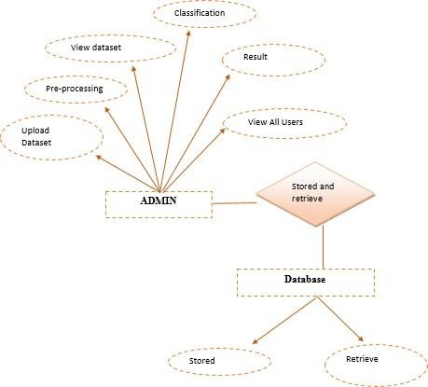

Figure 4.1 ER Diagram

This figure 4.1 shows the entity relationship diagram above explains the relationship between Admin and Database which are also called as entities. The attributes of the entity admin are upload data, pre-processing, view data set, classification, result and view all users. Similarly, the attributes of the entity database are stored and retrieve

DATA DICTIONARY:

Variable | Description
ID | Identification of the user
U Name | It is the name of the user
Date | Specific date of the tweets
Tweet | Short remark or the information posted on the social media

Table 4.1 Data Dictionary

UML DIAGRAMS

UML stands for Unified Modeling Language. It’s a rich language to model software solutions, application structures, system behavior and business processes. It is a standard visual modeling language intended to be used for modeling business and similar processes, analysis, design, and implementation of software-based system.

USE CASE DIAGRAM:
Use case diagrams give a graphic overview of the actors involved in a system, different functions needed by those actors and how these different functions interact. Use case diagrams are considered for high level requirement analysis of a system.

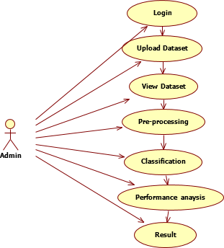

Figure 4.2 Use Case Diagram

This figure 4.2 shows the above use case diagram explains the relationship between the actor and functionality. Admin is the actor here who is related to the functionalities such as login, upload dataset, view dataset, pre-processing, classification, performance analysis, result. The use case diagram explains the flow and relationship between each functionality.

CLASS DIAGRAM:

Class diagram is basically a graphical representation of the static view of the system and represents different aspects of the application. Class diagrams are the main building block of any object- oriented solution. It shows the classes in a system, attributes, and operations of each class and the relationship between each class. So a collection of class diagrams represent the whole system. In a large system with many related classes, classes are grouped together to create class diagrams.

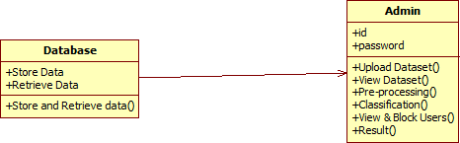

Figure 4.3 Class Diagram

This figure 4.3 shows the class diagram provided above has two classes, they are Database and the Admin. The class database holds store data and retrieve data attributes along with Store and Retrieve data() operation. The class admin holds Id and Password attributes along with few operation such as Upload Dataset(), View Dataset(), Pre-processing().

SEQUENCE DIAGRAM:

A sequence diagram shows object interactions arranged in time sequence. It depicts the objects involved in the scenario and the sequence of messages exchanged between the objects needed to carry out the functionality of the scenario. Sequence diagrams are typically associated with use case realizations in the Logical View of the system under development. Sequence diagrams are sometimes called event diagrams or event scenarios

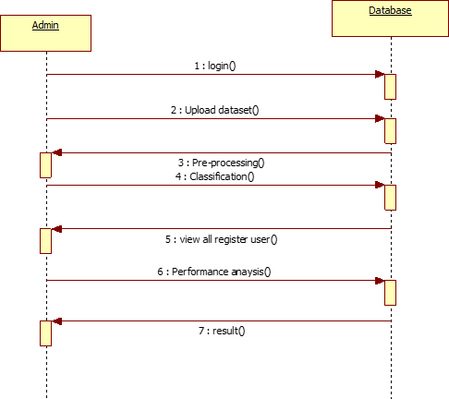

Figure 4.4 Sequence Diagram
This figure 4.4 shows Admin and Database are the two objects explained in the above sequence diagram where the sequences of operations between them are determined. Few of the messages transfer between the objects are login, uploading the dataset, pre-processing, classification, view all register users, performance analysis, result. The horizontal arrows are the messages exchanged between the admin and database object, which helps in determining the order in which the message occur.

DEPLOYMENT DIAGRAM

A deployment diagram is a diagram that shows the configuration of run time processing nodes and the components that live on them. Deployment diagrams are a kind of structure diagram used in modeling the physical aspects of an object-oriented system. They are often be used to model the static deployment view of a system (topology of the hardware).

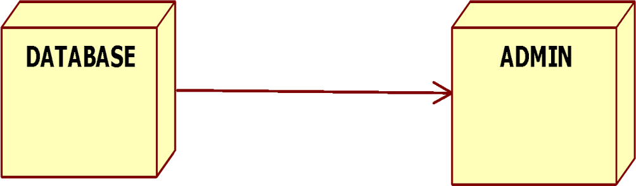

Figure 4.5 Deployment Diagram

This figure 4.5 shows the deployment diagram above shows the execution of the system. The components mentioned here are Database and Admin. It also explains how these components are connected.

SYSTEM ARCHITECTURE

5. SYSTEM ARCHITECTURE

ARCHITECTURE OVERVIEW

The architectural diagram shows that an input for processing is taken from the user and the other from dataset are preprocessed in order to avoid duplication and error values. Which is then undergoes implementation of various supervised learning algorithms. The outcome of each algorithm is again processed by ensemble which gives the most accurate result among the results of algorithms by voting classifier method and finally results are displayed in the GUI screen.

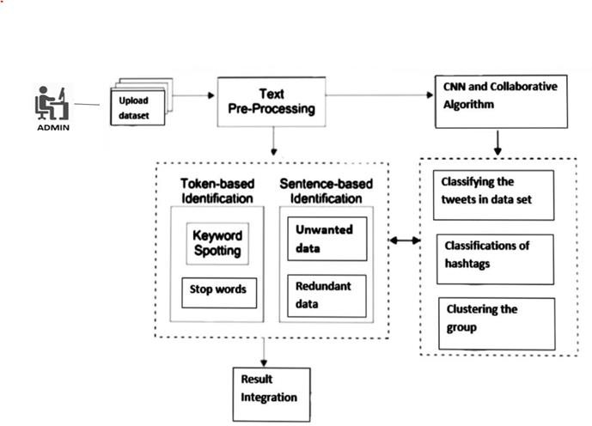

Figure 5.1 System Architecture

This figure 5.1 show Initially upload the data set, once the data set is uploaded text per-processing is done. The algorithm is used here are CNN and COLLABORATIVE algorithm.

Token based Classification and Sentence based Classification:
Here key word spotting is done, Keyword spotting is also defined as a separate, but related, problem in the context of document image processing. In document image processing, keyword spotting is the problem of finding all instances of a query word that exist in a scanned document image, without fully recognizing it. stop words are removed, and unwanted data and redundant data also removed.

Classifying the tweets in data set:
Publicly available tweets are fetched and classified and content expressed in tweets are extracted and normalized. This research uses domain-specific seed list to classify tweets. Semantic and syntactic analysis on tweets is performed to minimize information loss during the process of tweets classification.

Classification of hashtag:
Hashtags are classified into three categories, a topic which is closely connected to a certain hashtag, sentiment hashtags which express subjective opinions and sentiment-topic hashtags which indicate a certain target word and the sentiment words.

Clustering into groups:
Clustering is the task of dividing the population or data points into a number of groups such that data points in the same groups are more similar to other data points in the same group than those in other groups. In simple words, the aim is to segregate groups with similar traits and assign them into clusters.

Using the algorithm the classifying the tweets in data set, classifications of hash tags and clustering the groups all are done and finally Result is integrated.

MODULE DESINGS SPECIFICATION:

Module Specification A precise statement of the effects that a software module is required to achieve. It can be employed both by the implementer of the module, since it gives a definitive statement of the requirements that are imposed on the module, and by users of the module, since it gives a precise statement of what the module provides. A good module specification makes no commitment as to how the module's effects are achieved. In this project only one module:

ADMIN:

To provide following features-

- Register into our system.
- Login to our System.
- Only Authorized Admin can access to our System.
- Upload Related Dataset to Our System.
- Data pre-processing process takes place like (stop-word removal, Stemming, Tokenization) to remove the unwanted data.
- Classification of hash tags – Using Collaborative algorithm and CNN Algorithm classification of the hash tag takes place.
- Feature extraction - To predict the tweets keyword in which type of group Based on the username.
- Group Recommendation -To calculate Betweens value which means the users who is in more than one group. Classify the tweets in datasets into the groups by using Collaborative Filtering algorithm.
      - Remove all the redundant data.
      - Clustering the group by using CNN algorithm.
- Performance Analysis - To calculate the Algorithm accuracy by using Confusion matrix.
- Result- Generate the graph based on the number of tweets in each group.

SYSTEM IMPLEMENTATION

6.1 SYSTEMIMPLEMENTATION

SOURCE CODE:

Analysis.java
import CBF.Stem; import CBF.Stopwords; import CBF.replace; import dbServices.DB; import java.io.IOException; import java.io.PrintWriter; import java.sql.Connection; import java.sql.ResultSet; import java.util.Collection; import java.util.Map; importjava.util.Set;
import java.util.logging.Level; import java.util.logging.Logger;
import javax.servlet.RequestDispatcher; import javax.servlet.ServletException; import javax.servlet.http.HttpServlet;
import javax.servlet.http.HttpServletRequest; import javax.servlet.http.HttpServletResponse; import javax.servlet.http.HttpSession;
import pro.Classifer;

public class Analysis extends HttpServlet {

protected void processRequest(HttpServletRequest request, HttpServletResponse response) throws ServletException, IOException {
response.setContentType("text/html;charset=UTF-8"); PrintWriter out = response.getWriter();

try {

String feed="",status=""; Connection con=new DB().Con(); Classifercls = new Classifer(); Map <String, String> status1; Set<String>setob;
Collection col;
String sta;
String col1;
Stopwordsst=new Stopwords(); Stem stem=new Stem();

replace rep=new replace();
String tweets="",twitter_id="",user_id="",id="";
PreparedStatement p2 = con.prepareStatement("truncate table output"); p2.executeUpdate();
PreparedStatement pss124 = con.prepareStatement("select * from dataset "); ResultSetrs = pss124.executeQuery();
while(rs.next())
{
id=rs.getString("id");
twitter_id=rs.getString("uname"); user_id=rs.getString("dte");
tweets=rs.getString("tweet"); tweets=rep.remove(tweets); tweets=st.words(tweets); tweets=stem.stem(tweets);
status1 = cls.data(tweets); setob = status1.keySet();
col = status1.values(); sta = setob.toString();
col1 = col.toString(); sta=sta.replaceAll("[^a-zA-Z0-9]", "");

tweets = tweets.toLowerCase(); System.out.println("tweet: "+tweets); String[] arr = tweets.split(" ");
int cinema=0,sports=0,news=0;String keyword=""; int count=0;
String nstatus=""; for ( String ss : arr)
{
PreparedStatementpss =con.prepareStatement("select * from cinema where word='"+ss+"' "); ResultSetrss = pss.executeQuery();
System.out.println(pss); while(rss.next())
{
cinema=cinema+1; keyword+=rss.getString("word")+" "; System.out.println("Title :"+ss);
}
PreparedStatement pss1 = con.prepareStatement("select * from sports where word='"+ss+"' "); ResultSet rss1 = pss1.executeQuery();
System.out.println(pss1); while(rss1.next())
{
sports=sports+1; keyword+=rss1.getString("word")+" "; System.out.println("Emotion : "+ss);
}
PreparedStatement pss2 = con.prepareStatement("select * from news where word='"+ss+"' "); ResultSet rss2 = pss2.executeQuery();
System.out.println(pss2);

Data.java

import au.com.bytecode.opencsv.CSVReader; import com.oreilly.servlet.MultipartRequest; import dbServices.DB;
import java.io.File; importjava.io.FileReader; import java.io.IOException; import java.sql.Connection;
import java.sql.PreparedStatement; import java.sql.SQLException;
import javax.servlet.RequestDispatcher; import javax.servlet.ServletContext; import javax.servlet.ServletException; import javax.servlet.http.HttpServlet;
import javax.servlet.http.HttpServletRequest; import javax.servlet.http.HttpServletResponse;

protected void processRequest(HttpServletRequest request, HttpServletResponse response) throws ServletException, IOException {
response.setContentType("text/html;charset=UTF-8"); PrintWriter out = response.getWriter(); ServletContextsc=request.getSession().getServletContext();
MultipartRequest m=new MultipartRequest(request,sc.getRealPath("dataset")); File file=m.getFile("file");
String fname=file.getName();
String csvFile =sc.getRealPath("dataset")+"\\"+fname; CSVReader reader = null;
Connection con=new DB().Con();

try

{
PreparedStatementpaa= con.prepareStatement("truncate table dataset");

reader = new CSVReader(new FileReader(csvFile)); String[] line;
while ((line = reader.readNext()) != null)
{

String query="insert into dataset(id,uname,dte,tweet)values('"+line[0]+"','"+line[1]+"','"+line[2]+"','"+line[3]+"') ";
PreparedStatementps=con.prepareStatement(query); System.out.println(query);
ps.executeUpdate(); System.out.println(query);
}
out.println("<script type=\"text/javascript\">");
out.println("alert(\"Succesfully Updated for sql\")"); out.println("</script>"); RequestDispatcherrd=request.getRequestDispatcher("Collection.jsp"); rd.include(request,response);
} catch (IOException | SQLException e)
{
System.out.println(e);
}
}
@Override
protected void doGet(HttpServletRequest request, HttpServletResponse response) throws ServletException, IOException {
processRequest(request, response);
}
@Override
protected void doPost(HttpServletRequest request, HttpServletResponse response) throws ServletException, IOException {
processRequest(request, response);
}
@Override
public String getServletInfo() { return "Short description";
}

Load.java

import au.com.bytecode.opencsv.CSVReader; import dbServices.DB;
import java.io.FileReader; import java.io.IOException; import java.io.PrintWriter; import java.sql.Connection;
import java.sql.PreparedStatement; import java.sql.SQLException;
import javax.servlet.RequestDispatcher; import javax.servlet.ServletContext; import javax.servlet.ServletException; import javax.servlet.http.HttpServlet;
import javax.servlet.http.HttpServletRequest; import javax.servlet.http.HttpServletResponse;

public class Load extends HttpServlet {

protected void processRequest(HttpServletRequest request, HttpServletResponse response) throws ServletException, IOException {
response.setContentType("text/html;charset=UTF-8"); PrintWriter out = response.getWriter(); ServletContextsc=request.getSession().getServletContext(); String fname="words.csv";
String csvFile =sc.getRealPath("dataset")+"\\"+fname; CSVReader reader = null;
Connection con=new DB().Con();
try
{
reader = new CSVReader(new FileReader(csvFile)); String[] line;
while ((line = reader.readNext()) != null)
{

String query="insert into keywords(word)values('"+line[0]+"')"; PreparedStatementps=con.prepareStatement(query);
ps.executeUpdate(); System.out.println(query);
}
out.println("<script type=\"text/javascript\">");
out.println("alert(\"Succesfully Updated for sql\")"); out.println("</script>");

} catch (IOException | SQLException e)
{
System.out.println(e);
}
}
@Override
protected void doGet(HttpServletRequest request, HttpServletResponse response) throws ServletException, IOException {
processRequest(request, response);
}
@Override
protected void doPost(HttpServletRequest request, HttpServletResponse response) throws ServletException, IOException {
processRequest(request, response);
}
@Override

Admin_Login.jsp:

<%@ page language="java" contentType="text/html; charset=ISO-8859-1" pageEncoding="ISO-8859- 1"%>
<!DOCTYPE html PUBLIC "-//W3C//DTD HTML 4.01 Transitional//EN" "http://www.w3.org/TR/html4/loose.dtd">
<html>
<head>
<meta http-equiv="Content-Type" content="text/html; charset=ISO-8859-1">
<title>Emotion Correlation Mining Through Deep Learning Models on Natural Language Text</title>
</head>
<body style="background-color:LemonChiffon;">
<h1 style="color:AliceBlue;text-shadow: 0px 5px 6px black;" align="center">Emotion Correlation Mining Through Deep Learning Models on Natural Language Text</h1>
<br><br><br><br>
<p align="center" style="color:navy; font-size:30px; text-shadow: 0px 5px 6px black;">User Login</p>
<form action="loginaction.jsp">
<table align="center" style="width: 431px;height: 120px;font-size:30px;background:Lavender;text-align: center;border-radius: 10px;border: ridge;">
<tr><td style="color:black; font-family:Times New Roman">User Name </td><td><input type="text" name="name" required="" style="color: navy;border-radius: 4px;height: 25px;border: violet;font-weight: bold;text-align:center;"></td></tr>
<tr><td style="color:black; font-family:Times New Roman">Password</td><td><input type="password" name="pass" required="" style="color: navy;border-radius: 4px;height: 25px;border: violet;font-weight: bold;text-align:center;"></td></tr>
</table>
<p align="center"><input type="submit" value="Login" style="width: 120px;height: 38px;font- size:20px;border-radius: 6px;border: whitesmoke;background: wheat;"></p>
<p align="center" style="color:navy; font-size:25px;">If New User?<a href="User_Register.jsp" style="color: orangered;padding-left: 10px;">Click Here</a></p>
</form>

AddDataSet.jsp:

<%@ page language="java" contentType="text/html; charset=ISO-8859-1" pageEncoding="ISO-8859- 1"%>
<!DOCTYPE html PUBLIC "-//W3C//DTD HTML 4.01 Transitional//EN" "http://www.w3.org/TR/html4/loose.dtd">
<html>
<head>
<meta http-equiv="Content-Type" content="text/html; charset=ISO-8859-1">
<title>Emotion Correlation Mining Through Deep Learning Models on Natural Language Text</title>
</head>
<body style="background-color: Gainsboro;">
<h1 style="color: unset;text-shadow: 0px 5px 6px chocolate;" align="center">Emotion Correlation Mining Through Deep Learning Models on Natural Language Text</h1>
<br><br><br><br>
<p align="center" style="color: purple;font-size:30px;text-shadow: 0px 5px 6px tomato;">Upload Twitter Datasets</p>
<form action="Data" method="post" enctype="multipart/form-data">
<table align="center" style="width: 568px;height: 120px;font-size:30px;background:Cornsilk;text-align: center;border-radius: 10px;border: ridge;">
<tr><td style="color: black; font-family:Times New Roman">Choose Dataset</td><td><input type="file" name="file" required="" style="color:black;border-radius: 4px;height: 25px;border: violet;font-weight: bold;"></td></tr>
</table>
<p align="center"><input type="submit" value="Upload DataSet" style="width: 167px;height: 38px;font- size:20px;border-radius: 6px;border: whitesmoke;background: darkorange;"></p>
</form>
</body></html>

Detection.jsp:
<%@page import="dbServices.DB"%>
<%@ page language="java" contentType="text/html; charset=ISO-8859-1" pageEncoding="ISO-8859-1"%>
<!DOCTYPE html PUBLIC "-//W3C//DTD HTML 4.01 Transitional//EN" "http://www.w3.org/TR/html4/loose.dtd">
<html>
<head>
<meta http-equiv="Content-Type" content="text/html; charset=ISO-8859-1">
<title>View DataSets</title>
</head>
<%@page import="java.sql.*"%>

<%
Connection con=new DB().Con(); PreparedStatementoo=con.prepareStatement("select count(*)total from output"); ResultSetsa=oo.executeQuery();
int Total=0; if(sa.next())
{
Total=sa.getInt("total");
}
%>
<body style="background:AntiqueWhite;">
<h1 align="center" style="color: blue;text-shadow: 0px 3px 28px honeydew;">Extracting Word Embeddings from Tweets to Identify Groups</h1>
<h1 style="color: currentColor;text-shadow: 0px 2px 8px lavenderblush;" align="center">Group Recommendation(Hijacks Groups)</h1>
<h3 style="color: mediumvioletred;text-shadow: 0px 2px 8px lavenderblush;" align="left">&nbsp;&nbsp;&nbsp;&nbsp;&nbsp;&nbsp;&nbsp;&nbsp;&nbsp;&nbsp;Total Data's Count
:&nbsp;&nbsp;<%=Total%>&nbsp;&nbsp;&nbsp;&nbsp;&nbsp;&nbsp;&nbsp;&nbsp;&nbsp;&nbsp;&nbs
p;&nbsp;&nbsp;&nbsp;&nbsp;&nbsp;&nbsp;&nbsp;&nbsp;&nbsp;&nbsp;&nbsp;&nbsp;&nbsp;&nbsp;&n bsp;&nbsp;&nbsp;&nbsp;&nbsp;&nbsp;&nbsp;&nbsp;&nbsp;&nbsp;&nbsp;&nbsp;&nbsp;&nbsp;&nbsp; &nbsp;&nbsp;&nbsp;&nbsp;&nbsp;&nbsp;&nbsp;&nbsp;&nbsp;&nbsp;&nbsp;&nbsp;&nbsp;&nbsp;&nss

sp;&nbsp;
</h3>
<center>
<h2><a href="Remove.jsp?totalcount=<%=Total%>" style="text-decoration:none; ">1. Remove Redundant Data</a></h2><br>
</center>
<style>table, td,th,tr{
border-collapse: collapse; border:1px solid steelblue; padding: 5px;
}
</style>
<table align="center" border="1" style="width:1000px;text-align:center;">
<tr style="font-size:22px; color:purple;">
<th>ID</th>
<th>User_name</th>
<th>Date</th>
<th>Tweets</th>
<th>Status</th>

<%PreparedStatement query=con.prepareStatement("SELECT id,uname,dte,tweet,status FROM output"); ResultSetrs=query.executeQuery();
while(rs.next())
{
String id=rs.getString("id");
String uname=rs.getString("uname"); String dte=rs.getString("dte");
String tweet=rs.getString("tweet"); String status=rs.getString("status");

int finish=1;

{
<tr>
<th style="color:black;"><%=id%></th>
<th style="color:black;"><%=uname%></th>
<th style="color:black;"><%=dte%></th>
<thstyle="color:black;"><%=tweet%></th>
<thstyle="color:black;"><%=status%></th>
</tr><%
}
Else
{ %>
<tr>
<th style="color: red;"><%=id%></th>
<th style="color:red;"><%=uname%></th>
<th style="color:red;"><%=dte%></th>
<th style="color:red;"><%=tweet%></th>

SYSTEM TESTING

SYSTEMTESTING

The purpose of testing is to discover errors. Testing is the process of trying to discover every conceivable fault or weakness in a work product. It provides a way to check the functionality of components, sub-assemblies, assemblies and/or a finished product It is the process of exercising software with the intent of ensuring that the Software system meets its requirements and user expectations and does not fail in an unacceptable manner. There are various types of test. Each test type addresses a specific testing requirement.

UNIT TESTING

Unit testing is usually conducted as part of a combined code and unit test phase of the software lifecycle, although it is not uncommon for coding and unit testing to be conducted as two distinct phases.

Test strategy and approach:
Field testing will be performed manually and functional tests will be written in detail.

Test objectives:

    - All field entries must work properly.
    - Pages must be activated from the identified link.
    - The entry screen, messages and responses must not be delayed.

Features to be tested:

    - Verify that the entries are of the correct format
    - No duplicate entries should be allowed
    - All links should take the user to the correct page.

INTEGRATION TESTING

Software integration testing is the incremental integration testing of two or more integrated software components on a single platform to produce failures caused by interface defects.
The task of the integration test is to check that components or software applications, e.g. components in a software system or – one step up – software applications at the company level – interact without error.

Test Results: All the test cases mentioned above passed successfully. No defects encountered.

ACCEPTANCE TESTING
User Acceptance Testing is a critical phase of any project and requires significant participation by the end user. It also ensures that the system meets the functional requirements.

Test Results: All the test cases mentioned above passed successfully. No defects encountered.

TESTCASES

- Test Case Name: Data Collection and Uploading

Test Case Description: Twitter Datasets are collected which contains name of the user, time and date of the tweet and user tweets. Then the Dataset is uploaded
successfully.

Step 1

Step Description:

Dataset Uploaded to the system as Admin.

Expected Result:

Dataset uploaded successfully by the admin.
- Test Case Name: Data Preprocessing

Test Case Description : The Uploaded dataset is given as input for preprocessing step.
In this step uploaded dataset is preprocessed by removing the unwanted data.

Step 1

Step Description:

Remove Stop words like is, was, and, the etc.

Expected Result:

Stop words are removed successfully

Step 2

Step Description:

Stemming technique is applied to make the word composite

Expected Result:

Dataset is stemmed successfully

- Test Case Name: Modeling Social Graph

Test Case Description: From the preprocessed dataset, each community has been classified by using the collaborative filtering algorithm. Users are classified according to their community.

Step 1

Step Description:

Distance measured for the tweets and removed the replicating data

Expected Output:

Replicated data’s are removed

Step 2

Step Description:

Clustering of Nodes. After removing the replicated data’s, remaining tweets are clustered.

Expected Output:

Tweets are clustered successfully.

Step 3

Step Description: Betweens is calculated for each user tweets. User those who belongs to the same
community are detected

Expected Output:

Betweens is calculated successfully.

Step 4

Step Description:

By using collaborative filtering algorithm, communities are classified.

Expected Output:

Communities are classified into cinema, sports and news.

- Test Case Name: Content Analysis

Test Case Description: Tf/Idf Algorithm is implemented and rank is calculated for each community and overall rank is calculated.

Step 1

Step Description:

Redundant Data is removed by person correlation method

Expected Output:

Unnecessary data is removed

Step 2

Step Description:

Using TF/IDF Algorithm, score is calculated

Expected Output:

For Each tweets tf/idf score is calculated

Step 3

Step Description:

Rank is calculated for each community. For the classified community, the rank is calculated based on number of tweets.

Expected Output:

Rank for each community is calculated.

Step4

Step Description:

From the output step 3, the overall rank is calculated by comparing the three communities

Expected Output:

Overall Rank is calculated and output says that the particular community (result) only used by many users.

CONCLUSION

8. CONCLUSION

8.1 CONCLUSION

The project Emotion Correlation Mining through Deep Learning Models on Natural Language Text mines the correlation of emotions based on the emotion recognition result of state-of-the- art deep learning models. The errors caused by the dataset and models are cut down by designing three kinds of features and two deep neural-network models. The emotion correlation is mined through an emotion confusion law, which is undirected, and an emotion evolution law, which is directed.

APPENDICES

APPENDICES

SAMPLE SCREENS
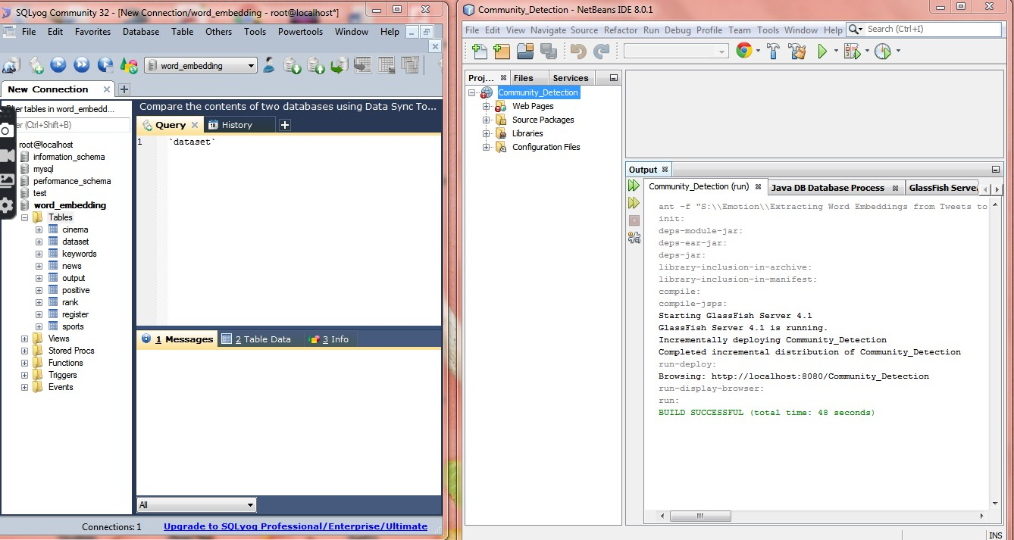

SQL Community Injection
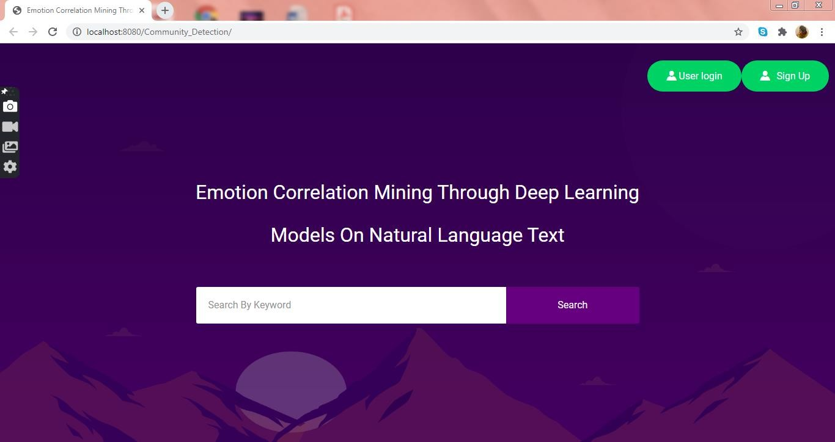
    - Local Host Entering

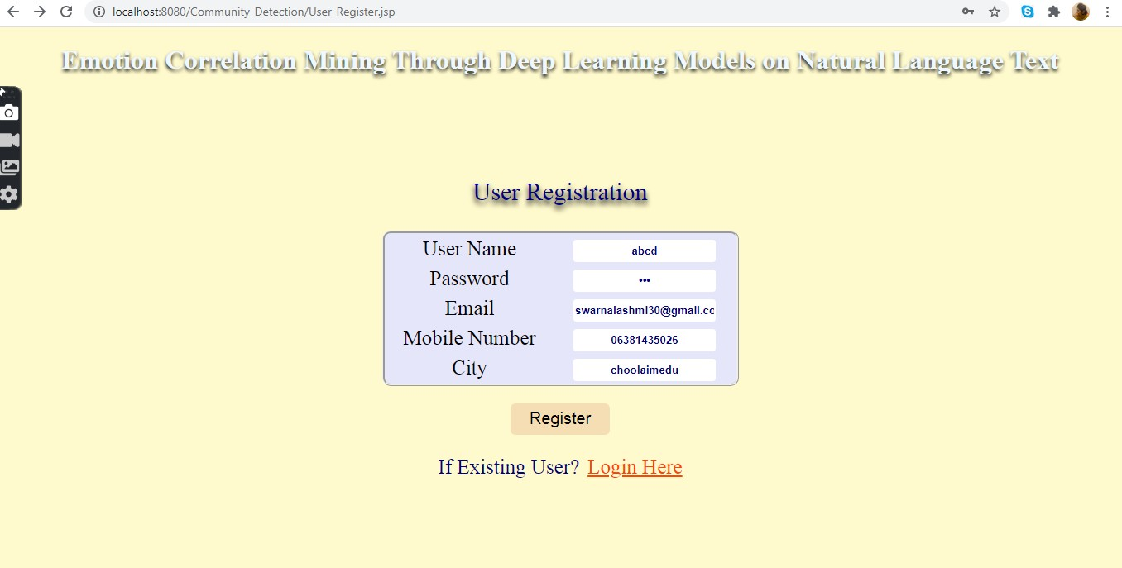

Emotion Correlation Mining on Natural Language Text – User Registration
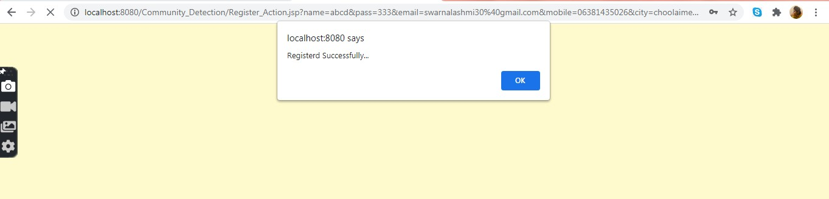
    - Local Host Registration Successful
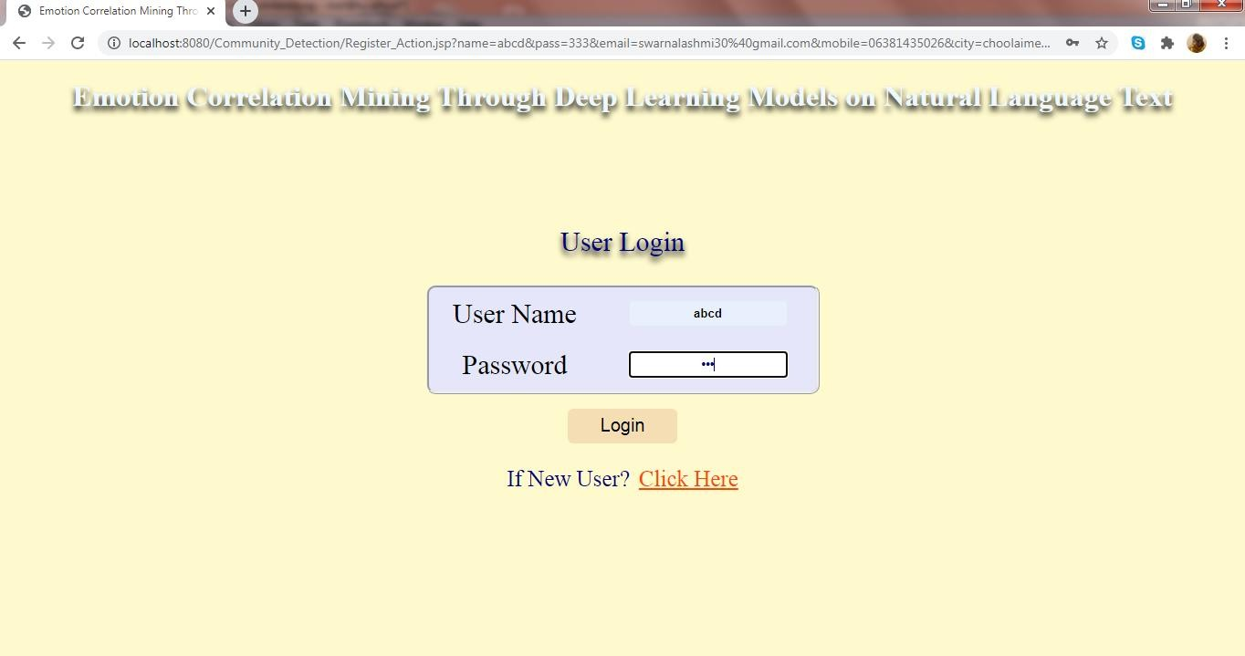

Emotion Correlation Mining on Natural Language Text – User Login
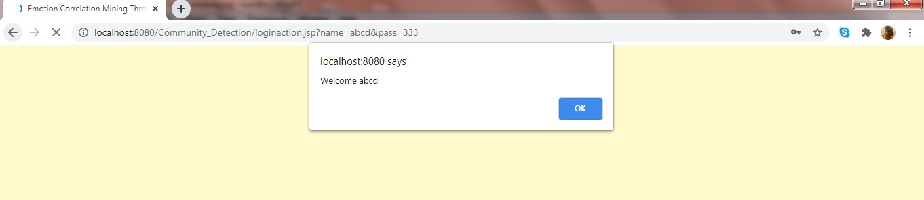
    - Emotion Correlation Mining on Natural Language Text – Welcoming
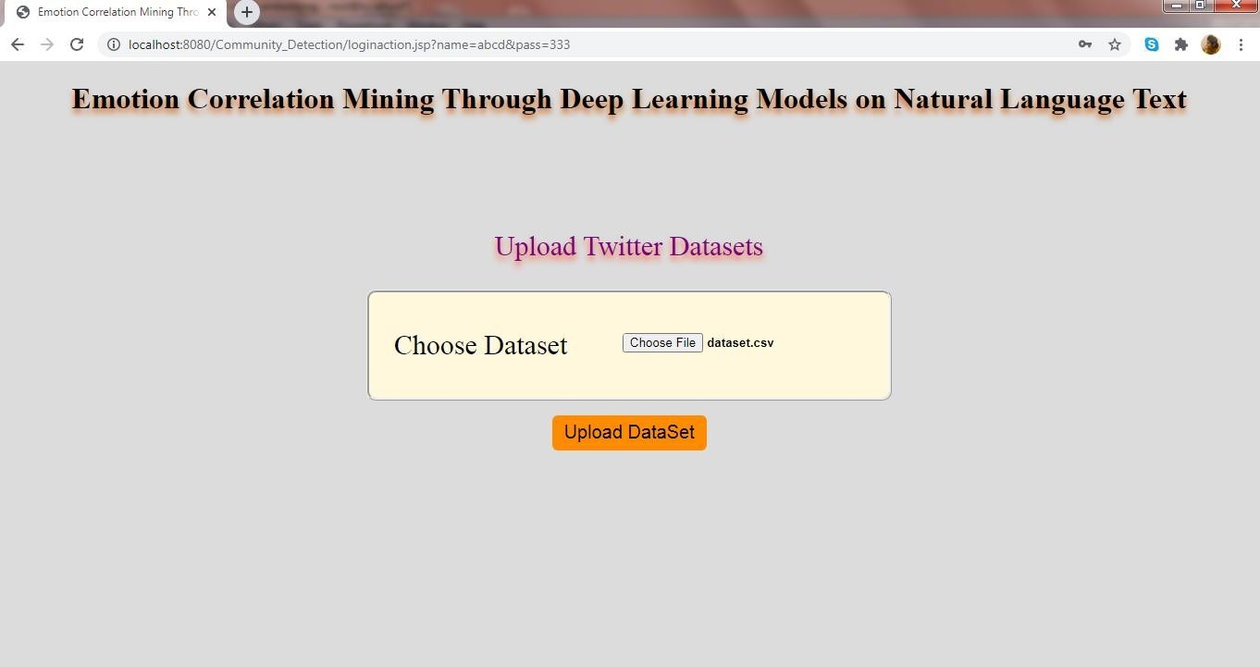
    - Emotion Correlation Mining on Natural Language Text – Upload Twitter Datasets
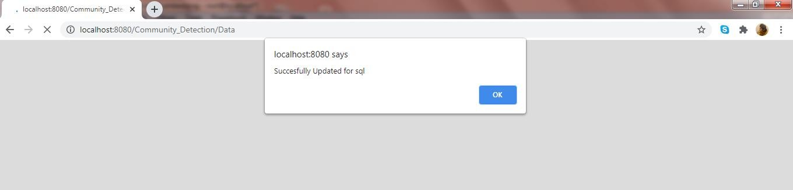
    - Emotion Correlation Mining on Natural Language Text – Upload Successful for SQL
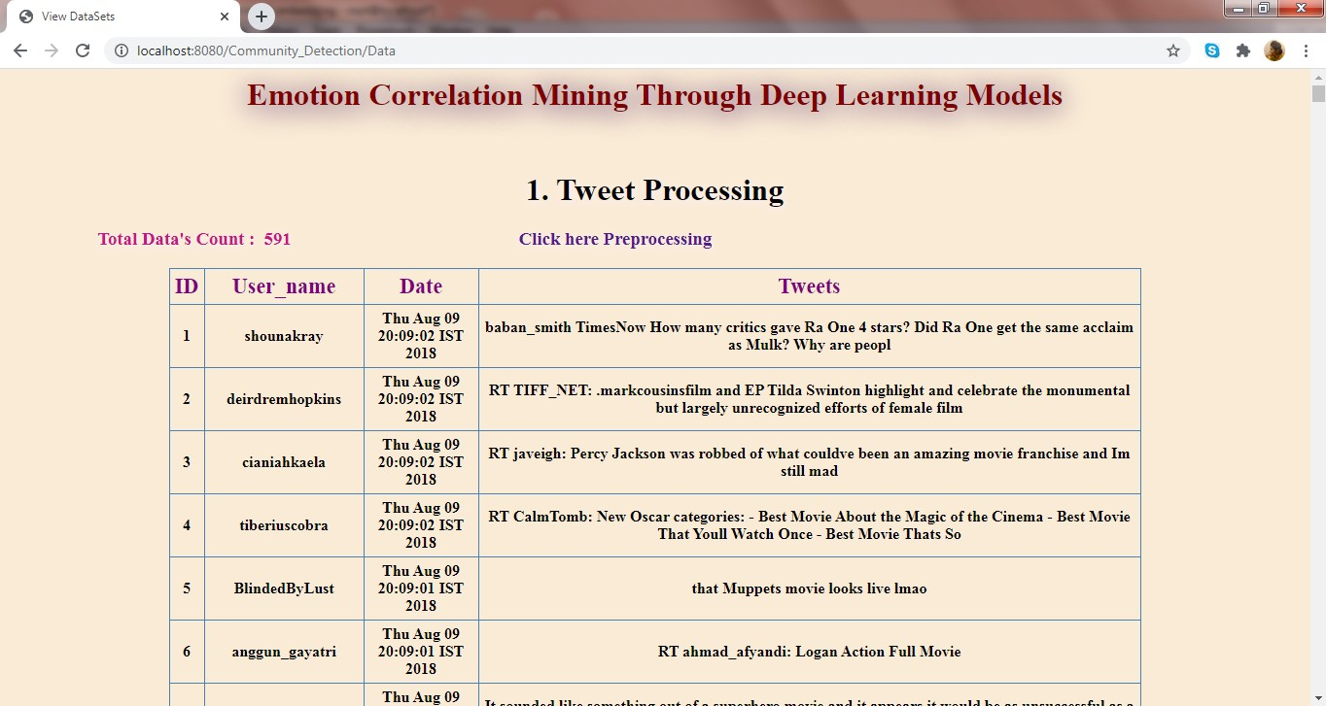
    - Emotion Correlation Mining on Natural Language Text – Tweet Processing
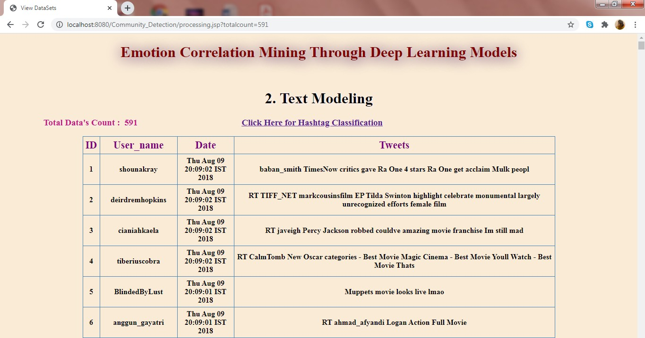
    - Emotion Correlation Mining on Natural Language Text – Text Modeling
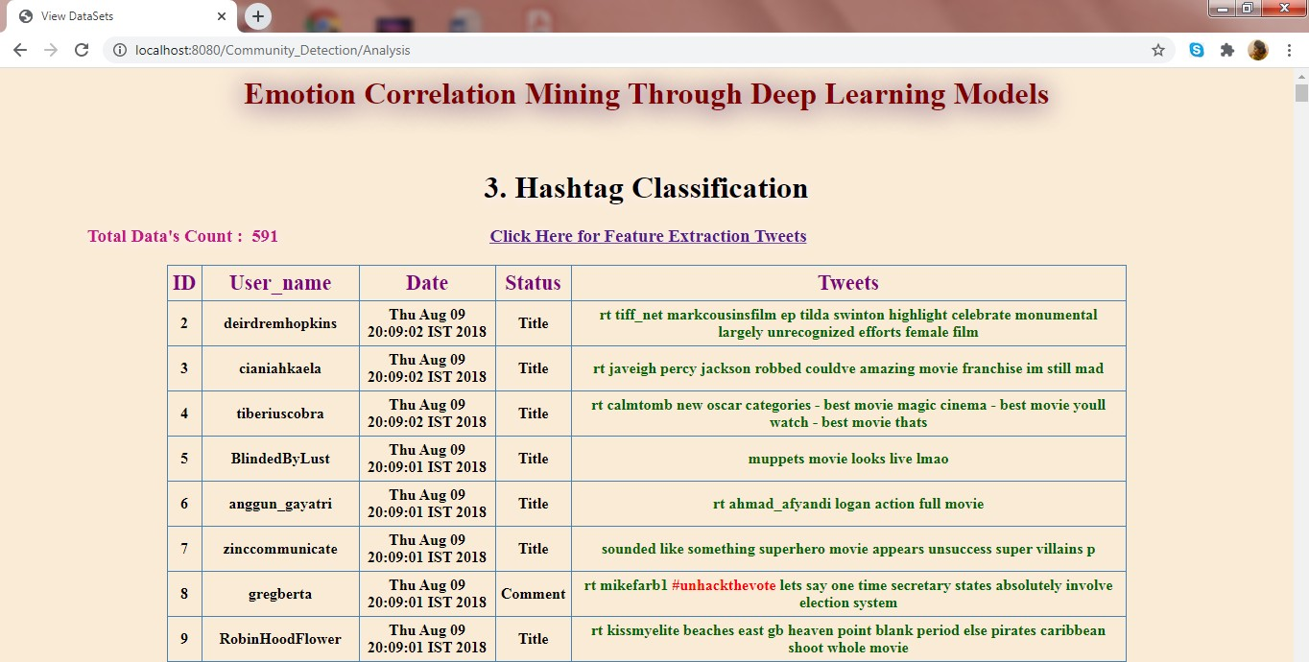
    - Emotion Correlation Mining on Natural Language Text – Hashtag Classification
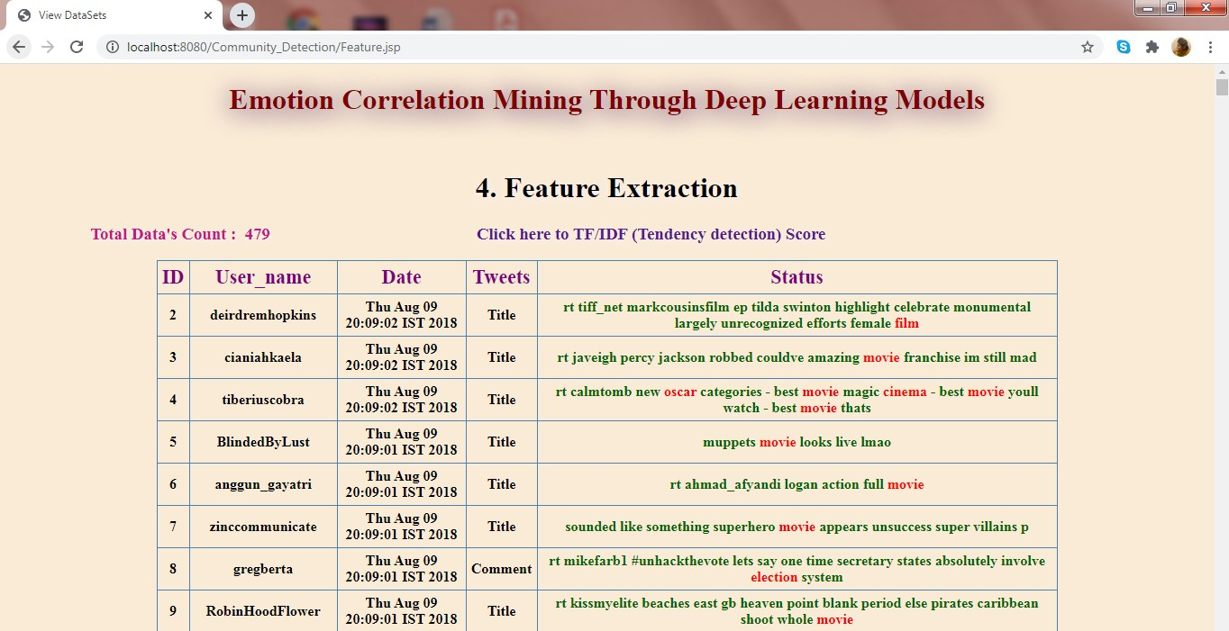
    - Emotion Correlation Mining on Natural Language Text – Feature Extraction
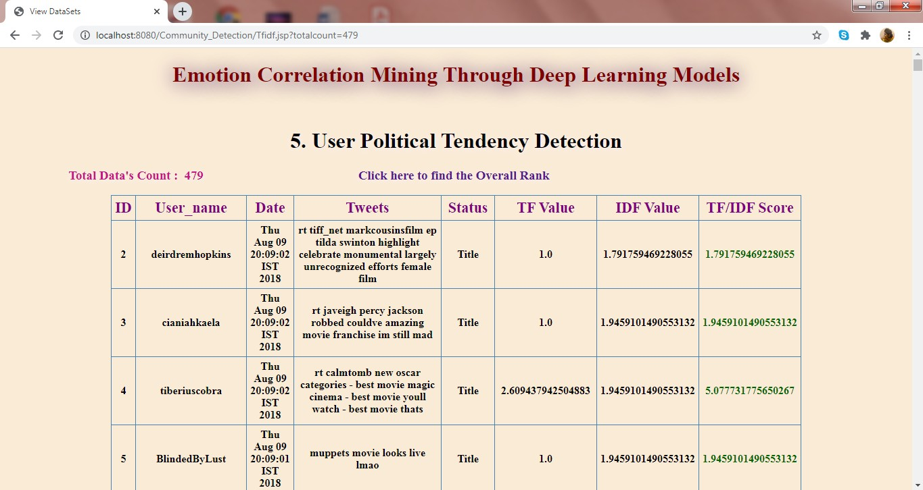
    - Emotion Correlation Mining on Natural Language Text – User Political Tendency Detection
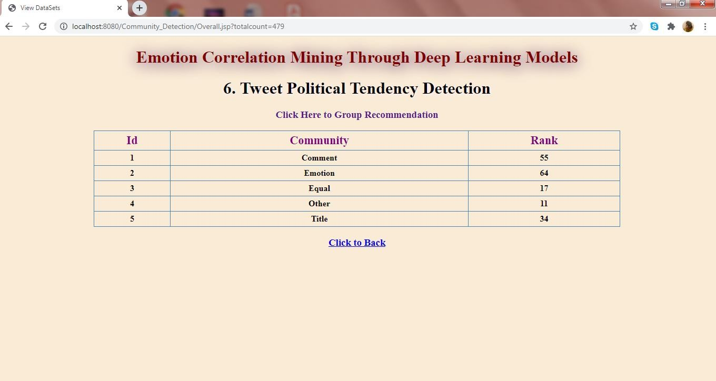
    - Emotion Correlation Mining on Natural Language Text – Tweet Political Tendency Detection
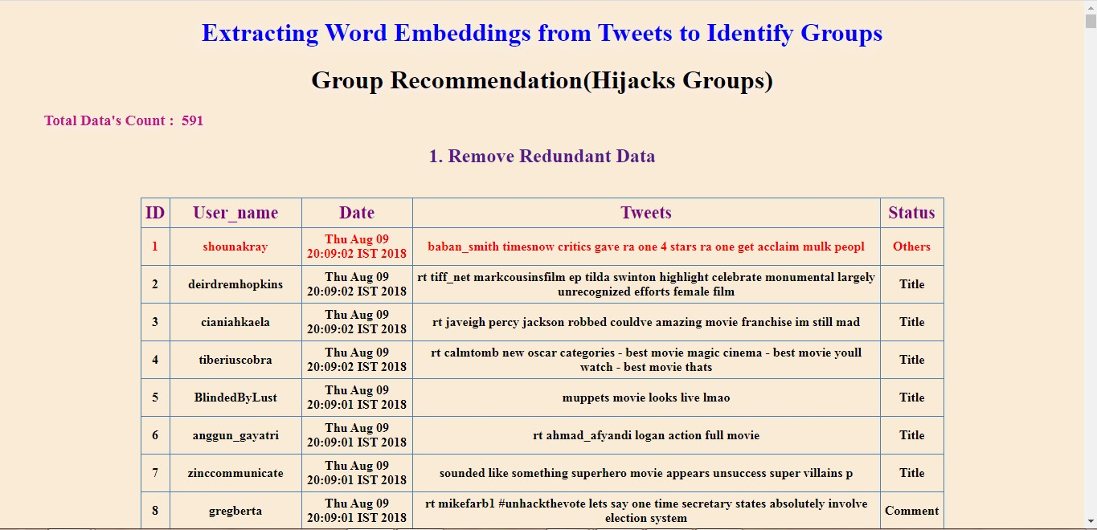
    - Emotion Correlation Mining on Natural Language Text – Remove Redundant Data

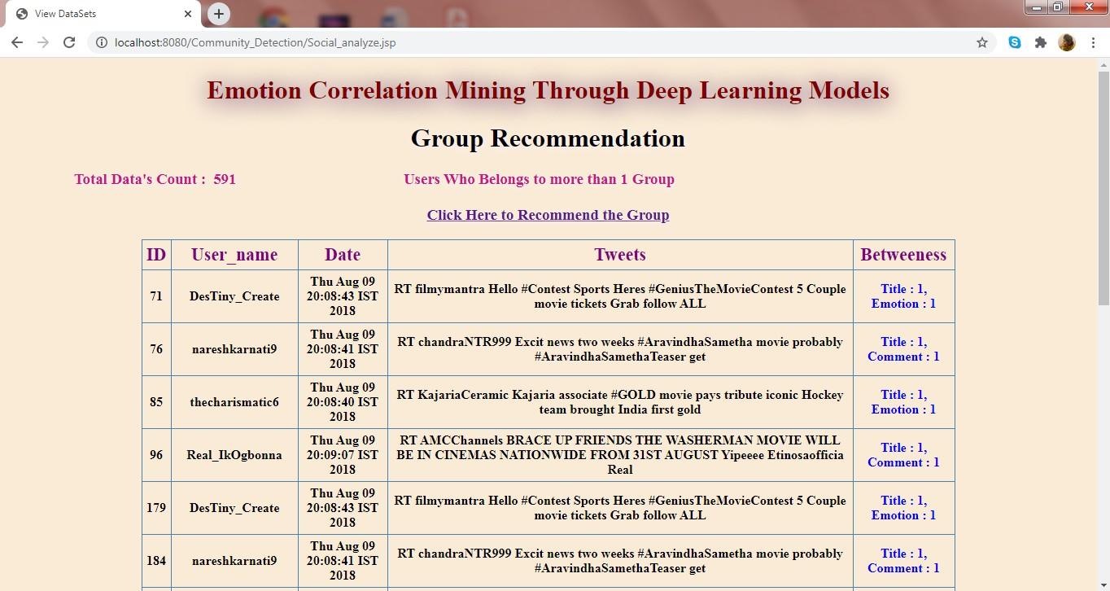
    - Emotion Correlation Mining on Natural Language Text – Group Recommendation
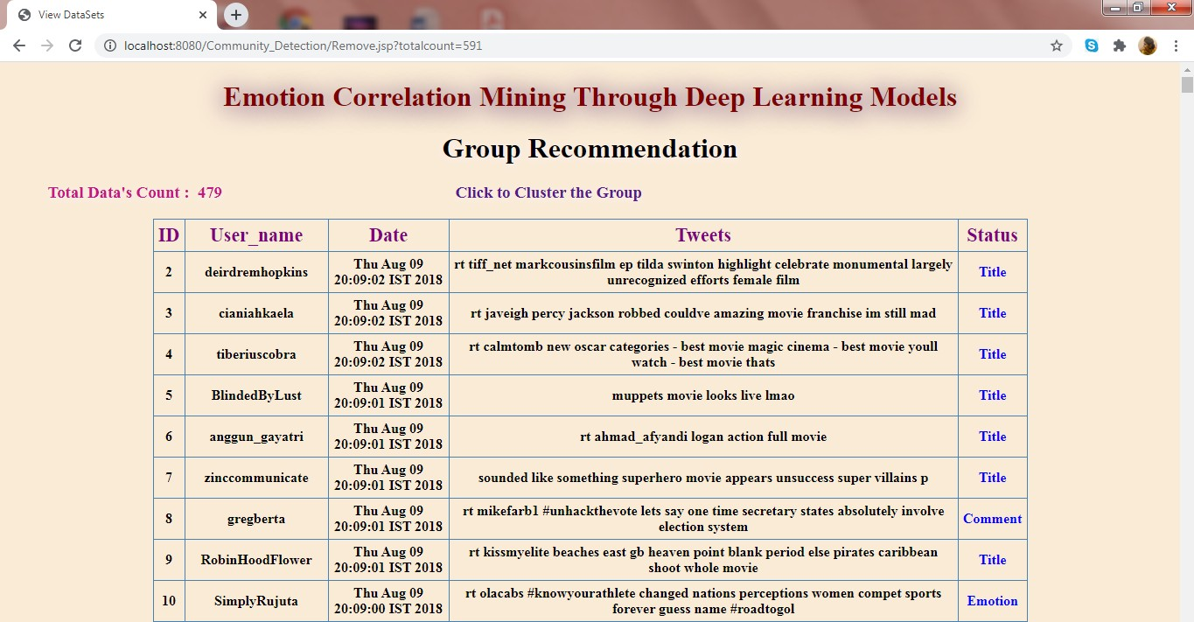
Emotion Correlation Mining on Natural Language Text – Group Recommendation
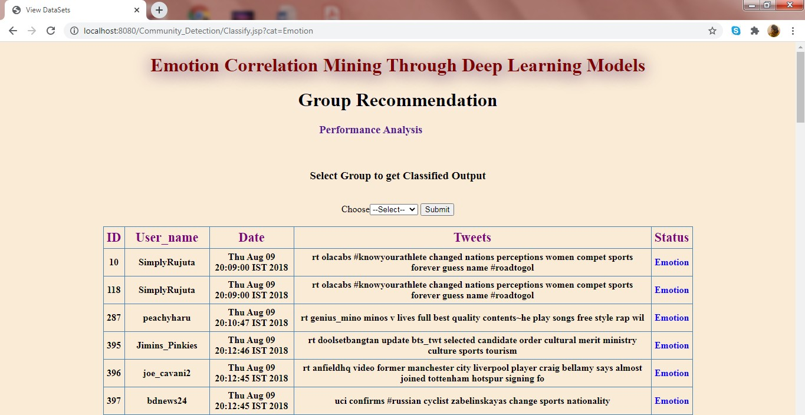
Emotion Correlation Mining on Natural Language Text – Group Recommendation
Comparison chart:
The earlier existing system coordinates only the twitter sentiment analysis. Involves classifying opinions in text into categories like "positive" or "negative" or "neutral". In our proposed system coordinates with deep learning methods finds out and categories mostly used communities such are title, emotion, comment etc.

EXISTING SYSTEM GRAPH:
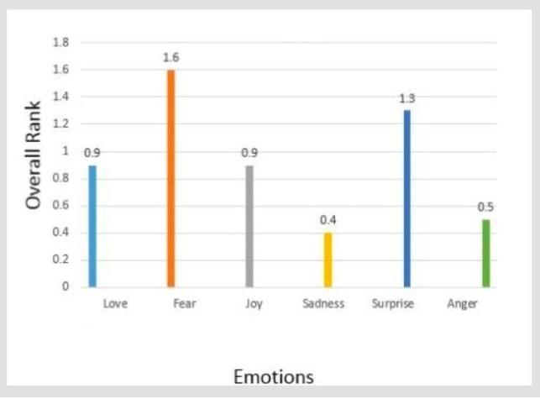

PROPOSED SYSTEM GRAPH:
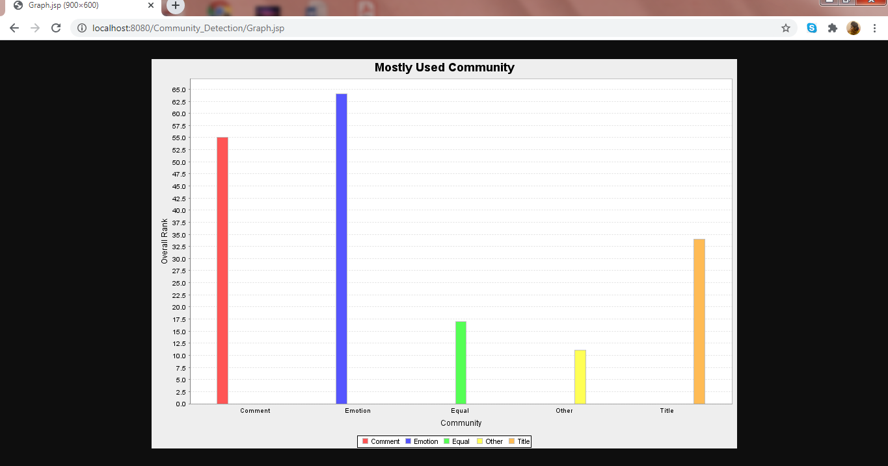

REFERENCES
REFERENCES

- A. Ali, S. Ghaderi, and S. Sohrabkhani. Forecasting electrical consumptionby integration of neural network, time series and anova. Applied Mathematics and Computation, 186(2):1753–1761,2007.

- C. Alzate, M. Espinoza, M. De, and J. Suykens. Identifying customer profiles in power load time series using spectral clustering. In Proceedings of International Conference on Artificial Neural Networks, pages 315–324. Springer,2009.

- C. Alzate and M. Sinn. Improved electricity load forecasting via kernel spectral clustering of smart meters. In Proceedings of IEEE 13th International Conference on Data Mining, pages 943–948. IEEE,2013

- X. Wang, X. Luo, and J. Chen, “Social sentiment detection of event via microblog,” in Proc. IEEE Int. Conf. Comput. Sci. Eng., 2013, pp.1051–1058.

- C. Strapparava and A. Valitutti, “WordNet affect: An affective extension of WordNet,” in Proc. LREC, vol. 4, 2004, p. 40.

- J. Staiano and M. Guerini, “DepecheMood: A lexicon for emotion analysis from crowd-annotated news,” 2014. [Online]. Available:arXiv:1405.1605.

- F. Strack and R. Deutsch, “The duality of everyday life: Dual-process and dual system models in social psychology,” in APA Handbook of Personality and Social Psychology, vol. 1. Washington, DC, USA: Amer. Psychol. Assoc., 2015, pp. 891–927.

- G. Badaro, H. Jundi, H. M. Hajj, and W. El-Hajj, “EmowordNet: Automatic expansion of emotion lexicon using English WordNet,” in Proc. 7th Joint Conf. Lexical Comput. Semantics, 2018, pp.86–93

- S. Mohammad, F. Bravo-Marquez, M. Salameh, and S. Kiritchenko, “SemEval-2018 task 1: Affect in tweets,” in Proc. 12th Int. Workshop Semantic Eval., 2018, pp.1–17.

